The Maids Moreton annual village carol singing is on Friday 22nd December. Everybody is welcome irrespective of singing ability to enjoy an evening of festive celebration and fun. We will meet in the car park area at St Edmunds Church at 6.30pm and then walk around the village. There will be mulled wine and light refreshments after the carol singing as a thank you. All money raised will be in support of the Children’s Society.
We would appreciate an indication of numbers for catering purposes. Could you please message Clare Hodgson on 07775 434200.

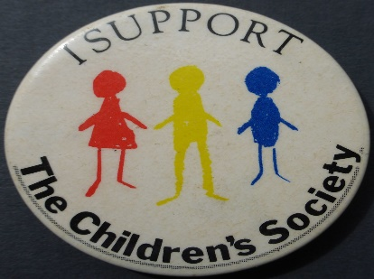
This Photo by Unknown Author is licensed under CC BY-SA-NC

